
Horne-Mudlitz VFW Post 6377 Monthly Newsletter
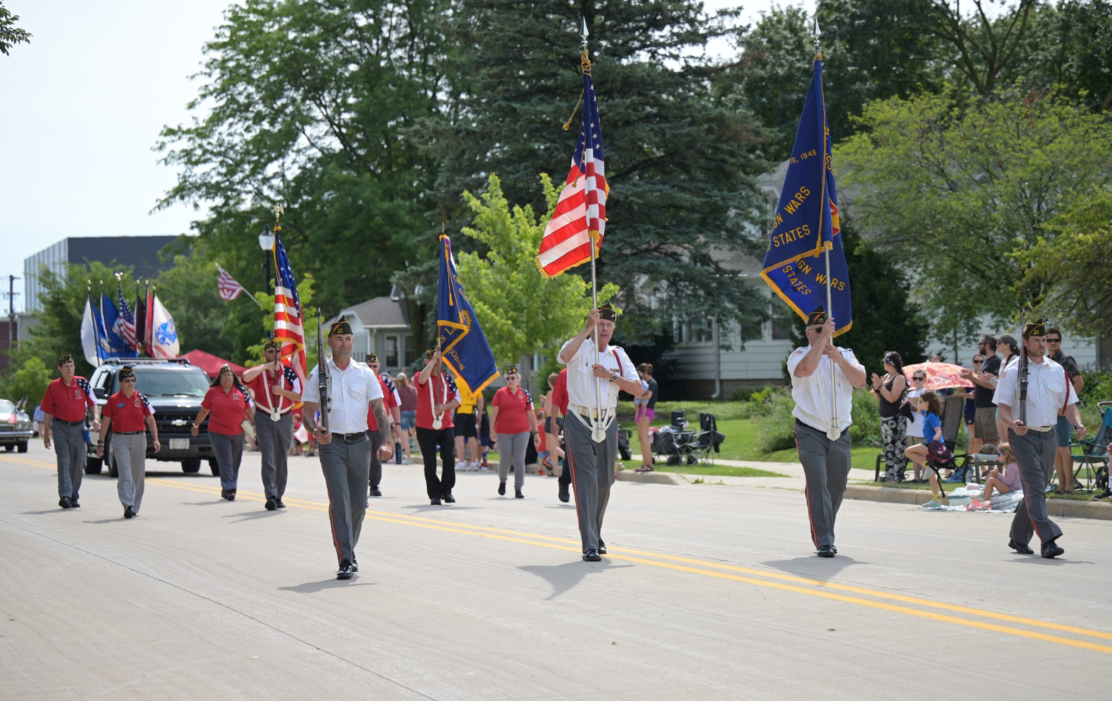
Commander’s Goal Mission:
To Recruit, retain, & mentor a stable membership base including all generations of veterans. To cultivate a membership that is well versed in institutional knowledge & actively involved all levels of the organization and in local community. To establish Posts with an established vision of service, leadership, and community outreach.
Post Meetings: 3rd Tuesdays at 7:30 p.m @ Horne Mudlitz Post 6377, Sussex WI
Next Post Meeting on Tuesday, September 16, 2025. Bar Opens at 6:00 p.m.

Rich Beatty, Commander, Jason Ciriacks, Sr. Vice Commander, Gabe Schaub, Jr. Vice Commander

  - September Post Minute Summary Highlights
- Meeting started at 7:30 p.m.
- By Laws Amendment – Name Change – Service Officer to Benefits Advisor
- Tom Heath was elected as our New National Council Member.
- Veteran History Project – Ethan Mueller, Va Caseworker for Congressman Scott Fritzgerald
- Julia Atkinson, Commander for American Legion 495, introduction and recruitment
- Motion to look at having a Q & A session with potential armed forces students at Hamilton High School about joining the Armed Services – Motion passed – In works for November.

- Announcements from District 2:
  - Post inspection will be conducted in the next quarter.
  - All application for Youth / Patriots Pen / Voice of Democracy scholarships are due by October 31, 2025

Post Social Event(s):
Calling all Comrades, we are looking at bolstering our Post morale and increasing interest with the Post, we are looking for ideas of things to do/places to join us for Social Hours for all Veterans and their mates. Current, thought for November is to join up at Village Bowl in Menomonee Falls at the bar area on Friday, November 14, 2025, at 8 p.m to secure lane(s). but any suggestions for future events are highly recommended, please send your RSVP or suggestions to hornemudlitzvfw@gmail.com or call the Post at (262) 820-9704.

Annual Tiddlywinks Tournament will be held on the weekend of February 14-15 at Thirsty Duck in Sussex. If you have a team or would like to participate in this tournament, please contact Jerry Strait at strait.damstr808@gmail.com for further information and registration.

Commander is currently working with The GOAT in Sussex to set up a Community Texas Holdem Tournament in the near future (Possibly in April 2026). Once finalized an announcement will be sent out to all.

Current Monthly Post Activities:
October
Sun |  | Mon |  | Tue |  | Wed |  | Thu |  | Fri |  | Sat
 |  |  |  |  |  | 1 |  | 2 |  | 3 |  | 4
 |  |  |  |  |  | Cards |  | Cards |  |  |  | Sheepshead
5 |  | 6 |  | 7 |  | 8 |  | 9 |  | 10 |  | 11
 |  | SAS  Toes/Nails |  |  |  | Cards |  | Cards American Legion Mtg 7 p.m. |  |  |  | Sheepshead
12 |  | 13 |  | 14 |  | 15 |  | 16 |  | 17 |  | 18
 |  | Scouts  Toes/Nails |  |  |  | Cards |  | Cards  Scrapbooking |  | Scrapbooking |  | Sheepshead  Scrapbooking
19 |  | 20 |  | 21 |  | 22 |  | 23 |  | 24 |  | 25
 |  | SAS  Toes/Nails |  | Post Meeting |  | Cards |  | Cards |  |  |  | Sheepshead
26 |  | 27 |  | 28 |  | 29 |  | 30 |  | 31
 |  | Scouts |  | Scouts |  | Cards |  | Cards
TAPS TAPS TAPS
In honor of our fallen comrades, the following members are remembered this month:

Myles Bruch
Earl Flaskrud
Thomas Rapp

Post Website: https://www.facebook.com/VFW6377/
Auxiliary Website: https://sussexauxiliary6377.com/
Email: hornemudlitzvfw@gmail.com
Contact: (262) 820-9704
Address: W232N6342 Waukesha Ave, Sussex, WI 53089-3953

